**CHAPTER ONE**

**INTRODUCTION**

* 1. **Background of the study**

On-line Exam System is very useful for Educational Institute to prepare an exam, safe the time that will take to check the paper and prepare mark sheets. It will help the Institute to testing of students and develop their skills. But the disadvantages for this system, it takes a lot of times when you prepare the exam at the first time for usage. And we are needs number of computers with the same number of students.

Online examination system helps students to offer a quick and easy way to appear for the test. It also provides the results immediately after the examination with 100% accuracy and security. Student can enter to perform exam only with their valid username and password. This examination contains multiple choice questions and appropriate number of options. There are no limitations on number of options and it can be randomized so same set of question will not appear to all student so it prevent manipulation. More than one option can be correct but the user can select only one option. This provides time limit. The user can see their results after completing the exam. This helps the students to write the exam from far distance and which can provide security and simplicity and other beneficial features to the user.

**1.2 Limitation of Existing System**

It cannot be used for personal and quick reference. Even the other staff members can make quick entries if the responsible person is not present.

|  |  |
| --- | --- |
| * Time Consuming for creating question paper * Time to check right and wrong answers * Calculation of Marks * Human error * Limitation of no of student can give examination at a time * Require teacher to monitor exam center * Student needs to come exam center for giving test |  |

### 1.3 Objectives and concentrations:

* Corporate between the data stored in the server of the Institution and our On-line Exam system. To deal with On-line System in an easy way and an efficient mannered. (connection process)
* Create strong and secrete data base that allow for any connection in a secret way, to prevent any outside or inside attacks.
* Specify a privilege for each person to allow each person use this system to create his own exam. And have a complete control on his exam.
* Allow each person to create more than one exam with different way to create variant questions.

### Scope and limitations:

* On-line Exam system is designed for Educational Institutes (like schools, universities, training centers).
* The system handles all the operations, and generates reports as soon as the test is finish, that includes name, mark, time spent to solve the exam.
* Allow students to see or display his answers after the exam is finish.
* The type of questions is only multiple choice or true and false.

**1.5 Software and Hardware Requirement**

* PHP
* MySQL Server
* NetBeans / FrontPage / NotePad
* Intel 3.0 ghz or higher processor
* 2 GB RAM
* 10 GB HDD Space

**CHAPTER TWO**

**FEASIBILITY STUDY**

**2.1 Introduction**

Feasibility study is a major factor that contributes to the analysis of the system. The decision of the System Analyst, where to design a particular system or not depend on its feasibility study. The feasibility study on this system is divided in the following three areas. All projects are feasible given unlimited resource and infinite time. It is both necessary and prudent to evaluate the feasibility of the project at the earliest possible time. Feasibility and risk analysis is related in many ways

Feasible study is an analysis and evaluation of a proposed project to determine if it (1) is technically feasible, (2) is feasible within the cost and (3) will be profitable. Feasible studies are almost always conducted where large sums are at stake. It is also called feasible analysis. My project ‘ONLINE EXAMINATION SYSTEM’ is feasible to develop and the cost is not so high.

1) Technical Feasibility*:* The firm has to purchase a machine with Pentium processor or higher. The computer must be running windows XP or any other higher version of windows. As the hardware and the software of developing the system are already available, the system is technically feasible. The concern will only be in which system the software is being developed and in which it will be implemented. The project is beneficial only if it can provide a successful and accurate access to the users.

2) Economic Feasibility:This is concerned with the cost incurred for development and implementation of the system, the maintenance of the system and the benefits derived from it. The hardware and software required for the system is already available. In this we examine the cost of developing the system with regard to what the organization can afford. The only cost involved is for coding, implementation and maintaining of the system. Hence the system is economically feasible.

3) Operational Feasibility:There are two aspects to operational feasibility. One aspect is that of technical information and other is Acceptance. Technical information determines if a system can provide correct results and Acceptance involves user acceptance to the computer system. Knowing that the system can provide easy and accurate access to a robotic vehicle, users will not hesitate to use the system for real situations in daily routine. The current system also provides options for speech recognition technique to control the bot but is less accessible and has a less coverage area. Thus the system that is going to be developed will be highly accurate and can process the voice signals at a much faster rate. With better algorithms the software is assured to give better results without compromising in the genre of quality on accessibility.

**2.2 System analysis**

After analyzing the requirements of the task to be performed, the next step is to analyze the problem and understand its context. The first activity in the phase is studying the existing system and other is to understand the requirements and domain of the new system. Both the activities are equally important, but the first activity serves as a basis of giving the functional specifications and then successful design of the proposed system. Understanding the requirements of a new system is more difficult and requires creative thinking and understanding of the existing system is also difficult, improper understanding of present system can lead diversion from solution.

* 1. **Requirement analysis**

1) User interfaces: User interface is simple and efficient enough to set up the user’s command. Apart from this user interface need not be used as the application runs in the background.

2) Hardware interface: Any smart phones or computer which have browser software. Processor above 500 MHz and 512 MB of RAM Internal memory with at least 100 MB free storage .

3) Security requirement: It has to be ensured that the saved information on this app is not tampered by another program, software or virus intentionally or unintentionally.

**2.4 Cost and benefit analysis**

* Cost of developing the system is not very high.
* Cost of maintaining the device is not very high.
* Cost of initial training is low enough.
* Cost of maintaining the running system is not enough.

**CHAPTER THREE**

**ANALYSIS AND DESIGN**

## 3.1 Introduction:

Design is the abstraction of a solution; it is a general description of the solution to a problem without the details. Design is view patterns seen in the analysis phase to be a pattern in a design phase. After design phase we can reduce the time required to create the implementation.

In this chapter we are introduce context diagram, models, system architecture, principal system object, design model and object interface.

## 3.2 Context Diagram:

This diagram represents what are the bounders and scope of **On-Line Exam** **System** project. It describes the main objective of the system and its entities involved.

**On-Line Exam system**

**Administrator**

**Student**

**Faculty**

Figure (3.2.1): the context diagram of On-line Exam System

**The Administrator can be done the following:**

* Create/delete accounts (add a list of faculty names and list of his student)
* Change password for Faculty/Student
* Create/ delete/update courses (subject).

**The Faculty can be done the following:**

* Change password.
* Insert questions.
* Specify the answers.
* Update mark of questions and answers.

**The Student can be done the following:**

* Change password.
* Choose exam.
* Review answers.
* See his exam mark.
* View other material.

## 3.3 Data Base Table:

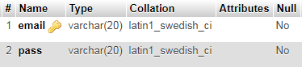

Table 3.3.1: Admin login

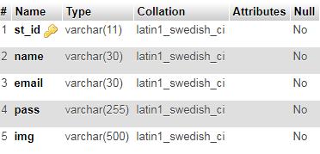

Table 3.3.2: Registration Table

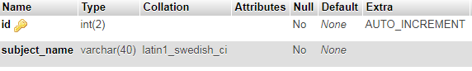

Table 3.3.3: Course Table

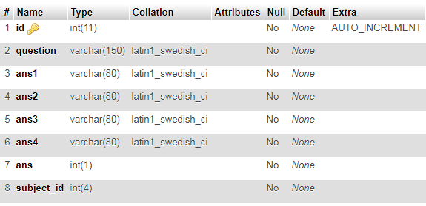

Table 3.3.4: Question Table

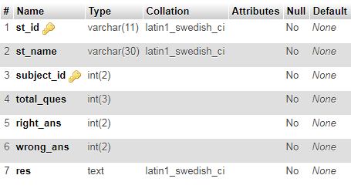

Table 3.3.5: Result Table

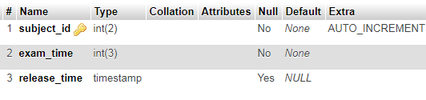

Table 3.3.6: Time Manage Table

## 3.3 Models:

### 3.3.1 Interaction model:

Is a dynamic model that shows how the system interacts with it’s environment. We use a data flow diagram.

#### 3.3.1.1 Use case diagram:

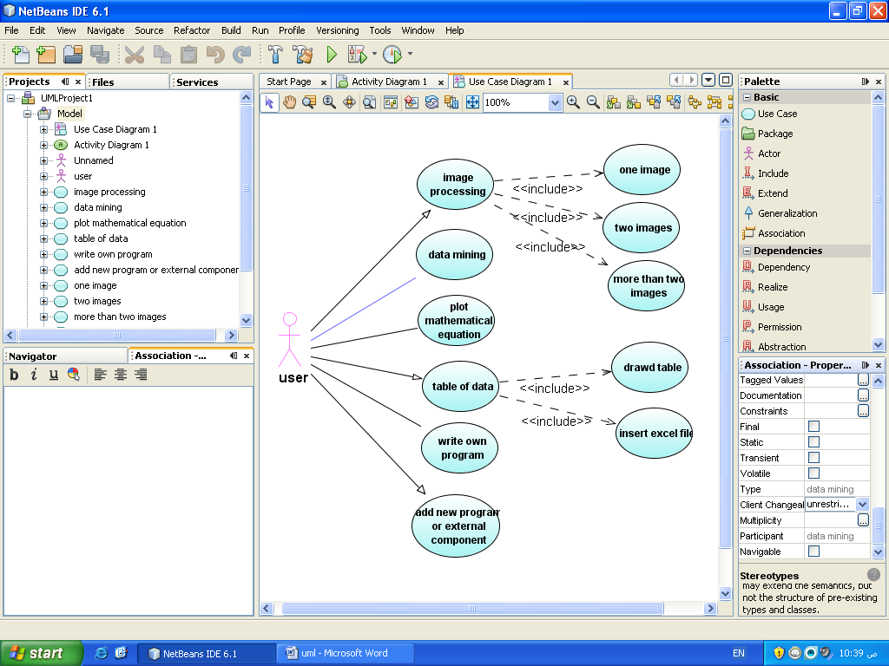

Administrator

Faculty

Student

# 



Figure (3.3.1.1): the basic function for each actor

### 3.3.2 Entity Relation model:

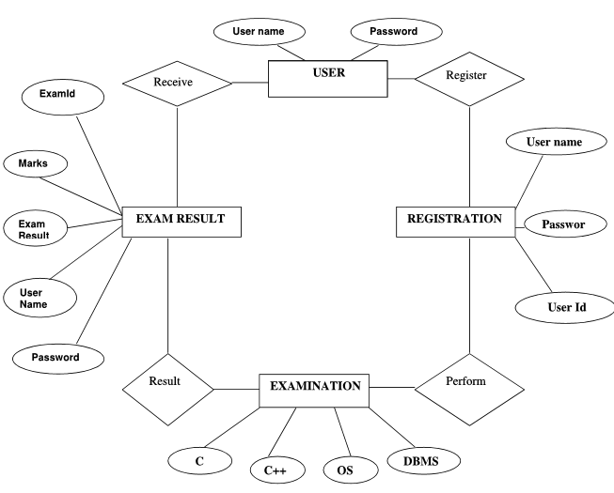

Figure (3.3.2.1): the ER diagram

### 3.3.3 DFD model:

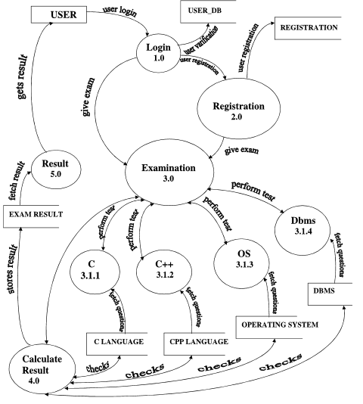

Figure (3.3.3.1): Data Flow Diagram

**CHAPTER FOUR**

**IMPLEMENTATION AND RESULT**

**4.1 User Interface:**

**4.1.1 Student Sign Up and Sign in form:**

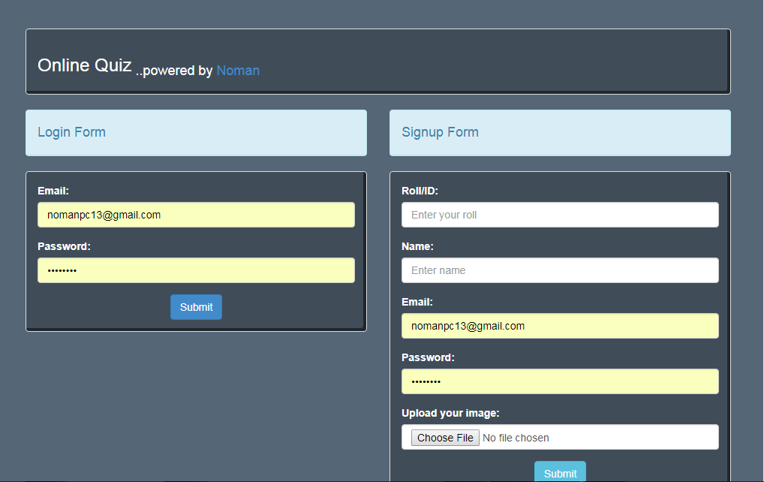

Figure 4.1.1: Student login and signup form

First of all student have to sign up to login this site if don’t sign up earlier. During register student have to provide their name, id, email, password by which they login this site and their image.

**4.1.2 Admin login form:**

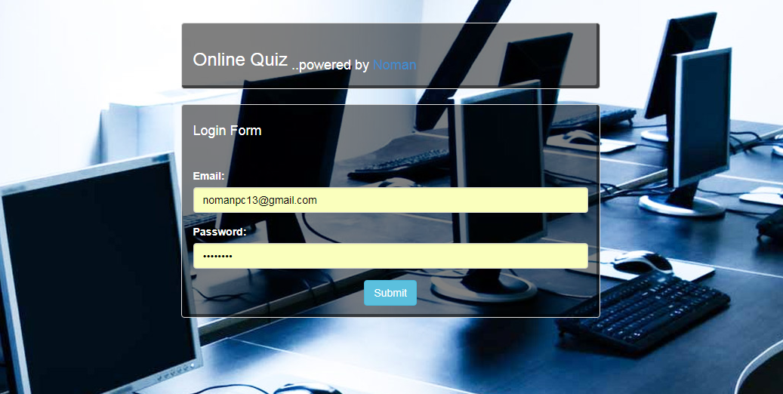

Figure 4.1.2: Admin login form

**4.2 Make Question:**

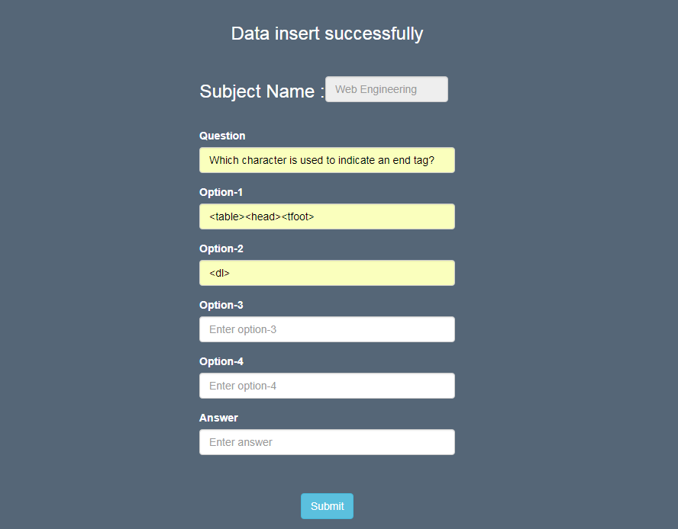

Figure 4.2: Make Question form

**4.2 Review Question Paper:**

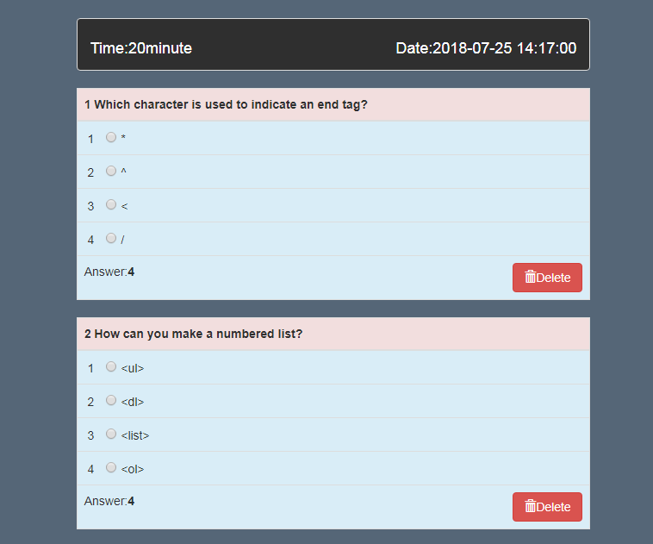

Figure 4.3: Review question before exam

Here Admin review the question paper before exam to check the accuracy of question paper. If there have any problem in any question Admin can delete that question. What is more this form shows when the exam will be started as well as the time of exam.

**4.4 Take Exam:**

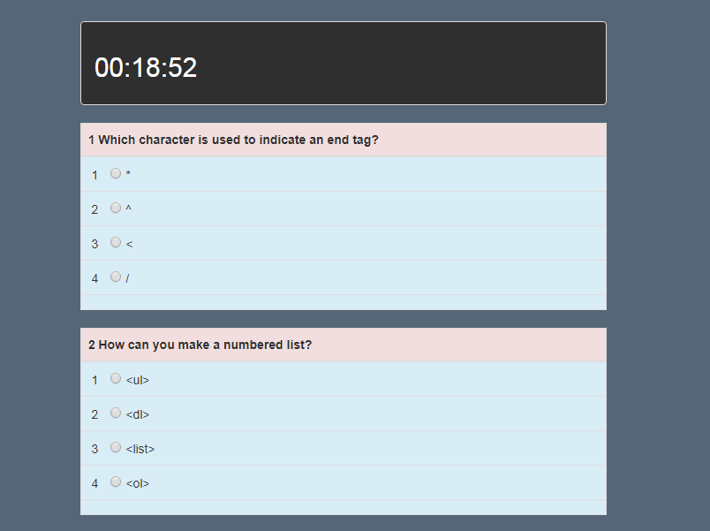

Figure 4.4.1: Taking exam

After selecting a subject by user then this question paper will be appeared if exam time is started. Student provide their exam within certain period of time. If they can’t finish within certain time , the answer sheet will automatically be submitted. There is a digital watch which time gradually decline as elapse of exam time. After provide their exam they will get their immediate result which is given below as a sample.

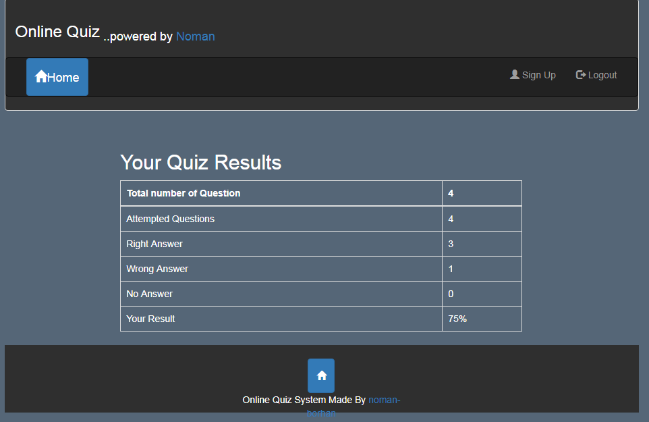

Figure 4.4.2: Immediate result after exam

**4.5 Recorded Result:**

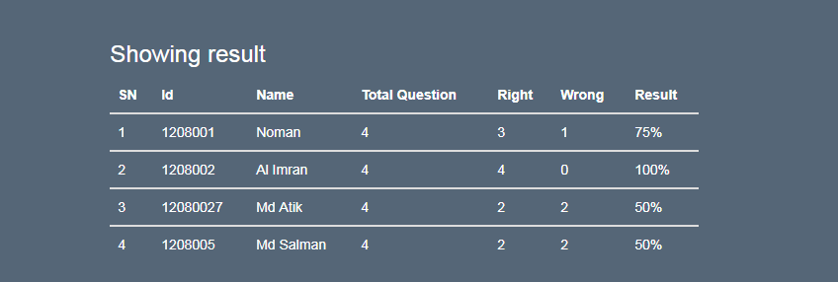

Figure 4.5: Exam result

After giving exam student’s result will be stored in data base. Admin or examinee can see their result.

**CHAPTER FIVE**

**CONCLUSION**

Online Examination has been developed and the system was tested with proper data. The system results in regular timing preparation of the required output .In comparison with the manual system, the benefit under a computer system considerable in to saving of manpower, working hour and efforts.

It can observe that the information required can be obtained with ease and accuracy in the computerized system. The user with minimum knowledge about computer can be able operate the system easily. Online massage has been provided to help the user to take necessary, correct action while using the system. Various validation techniques have been used to implement accuracy of data in all formats of input. The system has produced all the report required by the management .

This software can be used by any institute as it can be modified easily; additional features can be added without interrupting the normal functioning of the system.

**REFERENCES**

[1] https://www.w3schools.com

[2] http:// [www.scribd.com/doc/33852099/on-line-examiniation-system-project-report](http://www.scribd.com/doc/33852099/on-line-examiniation-system-project-report) .

[3]<http://whatis.techtarget.com/definition/0,,sid9_gci1103696,00.html>

[4] Software Requirements Specification for Problem Based Learning Module, Souman Mandal.

[5] Software Design Specification (SDS) Acropolis Course Management System.

[6] IEEE Recommended Practice for Software Requirements Specifications, Software Engineering Standards Committee of the IEEE Computer Society. 1998

[7] Software Requirements Specification for PPDP Contact Management System (CMS)

[8]<http://www.ehow.com/facts_5156877_preface-book.html>.

[9]<http://www.sil.org/lingualinks/literacy/referencematerials/glossaryofliteracyterms/WhatIsAPreface.htm>.

[10] <http://www.deftinfosystems.com/index.php/application/e-education-system/online-examination-system.html>.

[11] Software Requirement Specifications, Online Examination System.